Dalton Murray

Systems Analysis and Design

INT 6123 – Systems Analysis and Design

Dr. Andrew Makar

December 3, 2023

**IA #13 OO Use Case Realization**

**Question 3 - Figure 13-32 is an activity diagram for the use case Return books in the university library system. Do the following:**

**a. Develop a first-cut sequence diagram that only includes the actor and problem domain classes.**

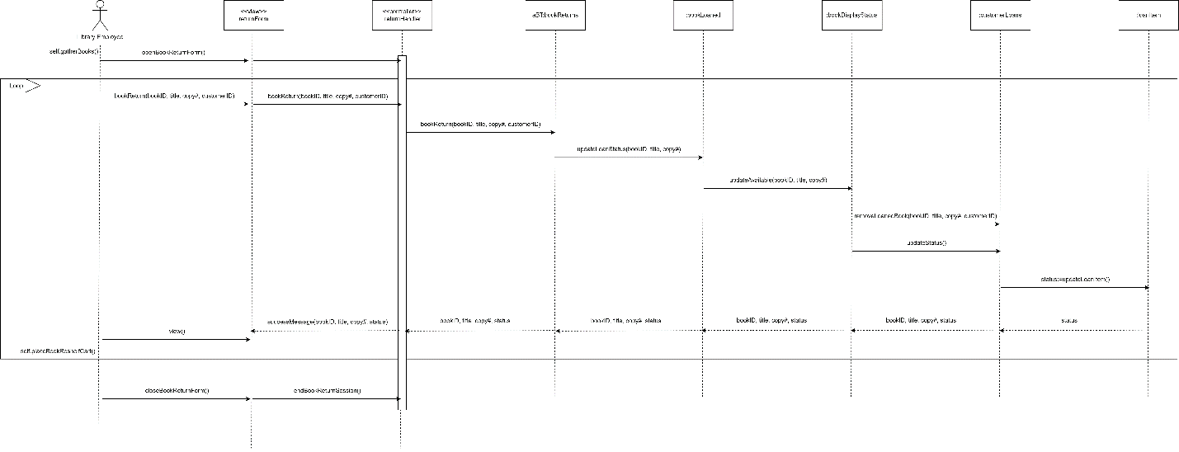

PDF: Attached separately

**b. Develop a design class diagram based on the domain class diagram.**

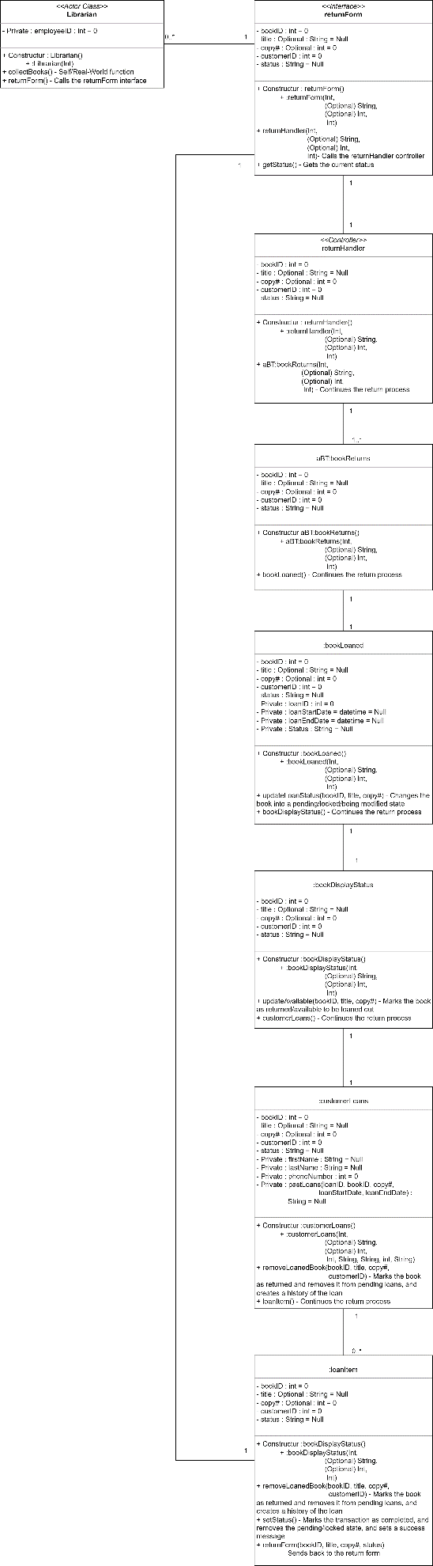

**References**

Satzinger, J. W., Jackson, R. B., & Burd, S. D. (2016). Systems analysis and design in a Changing World (7e ed.). Cengage Learning.

I have neither given nor received unauthorized aid in completing this work, nor have I presented someone else's work as my own.

*Dalton Murray*